Our Mission  Students will “…grow in Wisdom, Stature, and in Favor with God and Man.” Luke 2:52  At CCA, students grow:  Spiritually  Each student spends a minimum of five hours weekly in the study of God’s word and memorizes up to 36 passages in a year.  Academically  Students receive top awards at regional and state academic competitions through Private School Interscholastic Association (PSIA) and Texas Christian Athletic League (TCAL). Advanced Placement and Dual Credit classes are available, and CCA has a 100% acceptance rate to higher education institutions.  Socially  God is at work among our students on campus, through missions, and in community service projects.  Physically  Physical education is taught to all classes, and all middle and high school students have the opportunity to participate in our full Athletic Program.  The material was adapted from a Castle Hills Baptist School brochure. |  |   Brazos Valley  Cornerstone Christian Academy  3200 Cavitt Ave  Bryan, TX 77801 |  |  |   Pay for a Day Campaign  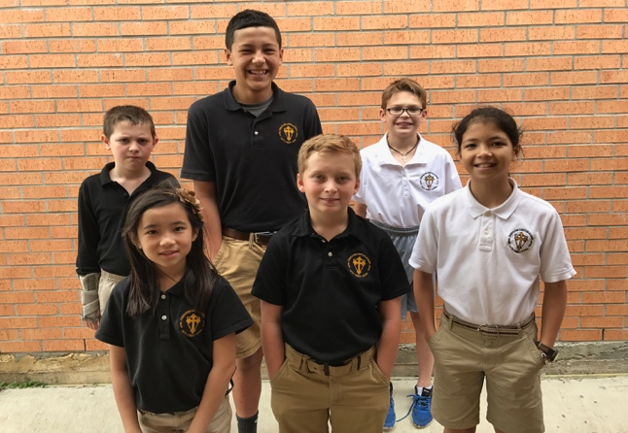  Funding an  Exceptional Education,  One Gift and One Day  at a Time.
Funding the Gap  The strong Christian education at CCA is supported by tuition and fees that are set with the priority of keeping the cost within reach of everyday families.  After tuition and fees have been taken into account, there remains a gap of $20,000 in operating expenses. This gap must be filled in order to fully fund the excellent education provided by CCA.  This amount is utilized in funding such things as teacher benefits, financial aid, classroom improvements, programs, resources, and a future building.  $20,000 Annual Need  (Budget Gap)  }  Breakdown  $20,000 Budget Gap  ÷ 67 days  $300 /day  *Surplus will go to the building fund!  Tuition and Fees  At a cost of $300, we need 67 individuals, families, or businesses to adopt a school day of their choice so that we can fully fund Cornerstone’s entire educational program. |  | Sponsor a Day  Pick a memorable date:  - Honor a child or loved one’s birthday  - Honor a wedding anniversary  - Honor a favorite teacher  - Highlight a memorable day  - Give “in memory” of a loved one  - Show your support of a CCA athletic team, club, or organization  - Highlight your business, church, or civic organization  Here’s how it works:  - You choose the day that you would like us to honor.  - Your sponsorship will be highlighted on the day that you choose.  - We will recognize your sponsorship in our weekly newsletters and through other social media.  - We will honor your sponsorship in chapel and continuously throughout the day in a variety of ways.  - We will display any memorabilia, or run a video presentation if you wish to supply them. |  |  | How to Sponsor a Day  Choose a day that is special to you. Pay for that day. Let’s fund the dream for kids, one day at a time!    “Pay for a Day” Commitment  Yes! We want to be a partner in the quest to fully fund the education of Cornerstone Christian Academy’s students.  Our “Pay for a Day” Commitment:  ________ day(s) at $300 = $___________ One time gift $50/month  Chose the day(s) you want to adopt:  Date(s): _____________ _____________  Date(s): _____________ _____________  No date preference  Dedicated in honor of  Dedicated in memory of  Name:_______________________ ________________________________  Your contact info  Name: ________________________________  Address: ______________________________  Zip: _________ Phone: _________________  Email: ____________________________

